The Stock Exchange of Hong Kong Limited takes no responsibility for the contents of this announcement, makes no representation as to its accuracy or completeness and expressly disclaims any liability whatsoever for any loss howsoever arising from or in reliance upon the whole or any part of the contents of this announcement.


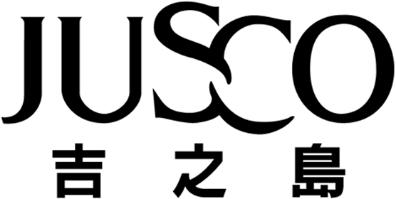
JUSCO STORES (HONG KONG) CO., LIMITED
吉之島(香港)百貨有限公司
(Incorporated in Hong Kong with limited liability)

CONNECTED TRANSACTION

The Company has entered into a licence agreement with Aeon Credit on 16th May, 2002 in respect of a shop space in the Company's Kornhill Store for a term of 2 years. This licence agreement takes effect from 13th May, 2002.

The licence agreement constitutes a connected transaction for the Company under Rule 14.25(1) of the Listing Rules.

PARTIES
1. Jusco Stores (Hong Kong) Co., Limited (the "Company") is a company listed on the Stock Exchange of Hong Kong Limited ("Stock Exchange") and is principally engaged in the operation of general merchandise stores; and

2. Aeon Credit Service (Asia) Company Limited ("Aeon Credit") is a company listed on the Stock Exchange and is principally engaged in the provision of consumer credit finance services which include the issuance of credit cards, the provision of vehicle financing, hire purchase financing and personal loan financing.

LICENCE AGREEMENT
Location Licence period Area Monthly licence fee

Shop No. L302, 3/F 13th May, 2002 to 846 sq. ft. HK$125,810.00
The Company's Kornhill store 12th May, 2004 (exclusive of rates and
management fees)

This licence agreement in effect renewed the existing license agreement between the Company and Aeon Credit in respect of the same shop space signed on 10th May, 2000. The licence agreement takes effect from 13th May, 2002.

The monthly licence fee was arrived at after arm's length negotiations taking into account the size and location of the shop area, the expected business volume and the prevailing rental market and are on normal commercial terms. The directors of the Company (including the independent non-executive director, Ms. Lam Pei, Peggy) consider that the terms of the licence agreement are fair and reasonable in so far as its shareholders are concerned.

CONNECTION BETWEEN THE PARTIES
As at the date of this announcement, AEON Co., Ltd. is a substantial shareholder of the Company, holding approximately 71.64% of the issued share capital of the Company. Since AEON Co., Ltd. also holds approximately 66.22% of the issued share capital of Aeon Credit as at the date of this announcement, Aeon Credit is an associate of AEON Co., Ltd. and the licence agreement constitutes connected transactions of the Company under the Listing Rules.

DISCLOSURE
As the annual licence fee payable by Aeon Credit to the Company in relation to the licence agreement is less than the higher of HK$10,000,000 or 3% of the audited consolidated net tangible assets of the Company as disclosed in its latest published audited accounts for the year ended 28th February, 2002, Rule 14.25(1) of the Listing Rules requires the Company to make this announcement and disclose such details in its annual report.

By Order of the Board

Kazumasa Ishii
Managing Director

Hong Kong, 16th May, 2002

Please also refer to the publish version of this announcement in the Hong Kong iMail.

